ASSIGNMENT 2

Importing Libraries

import numpy as np

import pandas as pd

import seaborn as sns

import matplotlib.pyplot as plt

Loading Dataset

df=pd.read_csv(r'C:\Users\LENOVO\Downloads\Churn_Modelling.csv')

df.shape

(10000, 14)

df.head()

 | Row | Cust | Sur | Credi | Geog | Ge | A | Te | Bala | NumOf | HasC | IsActiv | Estimat | Ex
 | Num | omer | na | tScor | raph | nd | g | nu | Bala | Produc | rCar | eMemb | edSalar | ite
 |  |  |  |  |  |  |  |  | nce
 | ber | Id | me | e | y | er | e | re | nce | ts | d | er | y | d
 |  | 1563 | Har |  | Fran | Fe | 4 |  |  |  |  |  | 101348.
0 | 1 | 1563 | grav | 619 | Fran | mal | 4 | 2 | 0.00 | 1 | 1 | 1 | 101348. | 1
0 | 1 | 4602 | grav | 619 | ce | mal | 2 |  |  |  |  |  | 88 | 1
 |  | 4602 | e |  | ce | e | 2 |  |  |  |  |  | 88
 |  | 1564 |  |  | Spai | Fe | 4 |  | 8380 |  |  |  | 112542.
1 | 2 | 1564 | Hill | 608 | Spai | mal | 4 | 1 | 8380 | 1 | 0 | 1 | 112542. | 0
1 | 2 | 7311 | Hill | 608 | n | mal | 1 | 1 | 7.86 | 1 | 0 | 1 | 58 | 0
 |  | 7311 |  |  | n | e | 1 |  | 7.86 |  |  |  | 58
 |  | 1561 | Oni |  | Fran | Fe | 4 |  | 1596 |  |  |  | 113931.
2 | 3 | 1561 | Oni | 502 | Fran | mal | 4 | 8 | 60.8 | 3 | 1 | 0 | 113931. | 1
2 | 3 | 9304 | o | 502 | ce | mal | 2 |  |  |  |  |  | 57 | 1
 |  | 9304 | o |  | ce | e | 2 |  | 0 |  |  |  | 57
 |  | 1570 | Bon |  | Fran | Fe | 3 |  |  |  |  |  | 93826.6
3 | 4 | 1570 | Bon | 699 | Fran | mal | 3 | 1 | 0.00 | 2 | 0 | 0 | 93826.6 | 0
3 | 4 | 1354 | i | 699 | ce | mal | 9 |  |  |  |  |  | 3 | 0
 |  | 1354 | i |  | ce | e | 9 |  |  |  |  |  | 3
 |  | 1573 | Mit |  | Spai | Fe | 4 |  | 1255 |  |  |  | 79084.1
4 | 5 | 1573 | chel | 850 | Spai | mal | 4 | 2 | 10.8 | 1 | 1 | 1 | 79084.1 | 0
4 | 5 | 7888 | chel | 850 | n | mal | 3 |  |  |  |  |  | 0 | 0
 |  | 7888 | l |  | n | e | 3 |  | 2 |  |  |  | 0
df.tail()
 | Row | Cust | Sur | Cred | Geo | Ge | A | Te | Bala | NumOf | Has | IsActiv | Estima | Ex
 | Num | omer | na | itSco | grap | nd | g | nu | Bala | Produc | CrC | eMemb | tedSala | ite
 |  |  |  |  |  |  |  |  | nce
 | ber | Id | me | re | hy | er | e | re | nce | ts | ard | er | ry | d
9
9 | 9996 | 1560 | Obij | 771 | Fran | Ma | 3 | 5 | 0.00 | 2 | 1 | 0 | 96270.6 | 0
9 | 9996 | 6229 | iaku | 771 | ce | le | 9 |  |  |  |  |  | 4 | 0
5

 | Row | Cust | Sur | Cred | Geo | Ge | A | Te | Bala | NumOf | Has | IsActiv | Estima | Ex
 | Num | omer | na | itSco | grap | nd | g | nu | Bala | Produc | CrC | eMemb | tedSala | ite
 |  |  |  |  |  |  |  |  | nce
 | ber | Id | me | re | hy | er | e | re | nce | ts | ard | er | ry | d
9 |  |  | Joh |  |  |  |  |  | 573
9 |  | 1556 | Joh |  | Fran | Ma | 3 |  | 573 |  |  |  | 101699.
9 | 9997 | 1556 | nsto | 516 | Fran | Ma | 3 | 10 | 69.6 | 1 | 1 | 1 | 101699. | 0
9 | 9997 | 9892 | nsto | 516 | ce | le | 5 |  |  |  |  |  | 77 | 0
9 |  | 9892 | ne |  | ce | le | 5 |  | 1 |  |  |  | 77
6 |  |  | ne |  |  |  |  |  | 1
9 |  |  |  |  |  | Fe
9 |  | 1558 |  |  | Fran | Fe | 3 |  |  |  |  |  | 42085.5
9 | 9998 | 1558 | Liu | 709 | Fran | ma | 3 | 7 | 0.00 | 1 | 0 | 1 | 42085.5 | 1
9 | 9998 | 4532 | Liu | 709 | ce | ma | 6 |  |  |  |  |  | 8 | 1
9 |  | 4532 |  |  | ce | le | 6 |  |  |  |  |  | 8
7 |  |  |  |  |  | le
9 |  |  | Sab |  | Ger |  |  |  | 750
9 |  | 1568 | Sab |  | Ger | Ma | 4 |  | 750 |  |  |  | 92888.5
9 | 9999 | 1568 | bati | 772 | man | Ma | 4 | 3 | 75.3 | 2 | 1 | 0 | 92888.5 | 1
9 | 9999 | 2355 | bati | 772 | man | le | 2 |  |  |  |  |  | 2 | 1
9 |  | 2355 | ni |  | y | le | 2 |  | 1 |  |  |  | 2
8 |  |  | ni |  | y |  |  |  | 1
9 |  |  |  |  |  | Fe |  |  | 130
9 |  | 1562 | Wal |  | Fran | Fe | 2 |  | 130 |  |  |  | 38190.7
9 | 10000 | 1562 | Wal | 792 | Fran | ma | 2 | 4 | 142. | 1 | 1 | 0 | 38190.7 | 0
9 | 10000 | 8319 | ker | 792 | ce | ma | 8 |  |  |  |  |  | 8 | 0
9 |  | 8319 | ker |  | ce | le | 8 |  | 79 |  |  |  | 8
9 |  |  |  |  |  | le |  |  | 79

Visualizations

1. Univariate

sns.distplot(df['EstimatedSalary'],hist=True)

C:\Users\LENOVO\anaconda3\lib\site-packages\seaborn\distributions.py:2619: FutureWarning: `distplot` is a deprecated function and will be removed in a future version. Please adapt your code to use either `displot` (a figure-level function with similar flexibility) or `histplot` (an axes-level function for histograms).

warnings.warn(msg, FutureWarning) <AxesSubplot:xlabel='EstimatedSalary', ylabel='Density'>
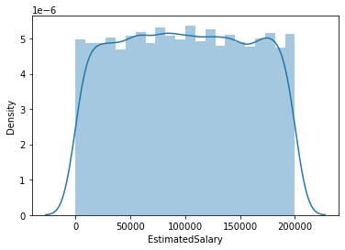

2. Bivariate

sns.relplot(x='Age',y='Balance',data=df)

<seaborn.axisgrid.FacetGrid at 0x1fd190d2070>
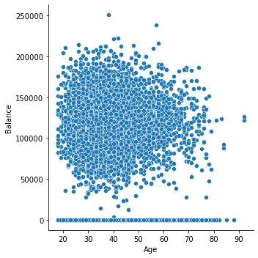

sns.catplot(x='Geography',y='CreditScore',data=df)

# for categorical data

<seaborn.axisgrid.FacetGrid at 0x1fd194e8d90>
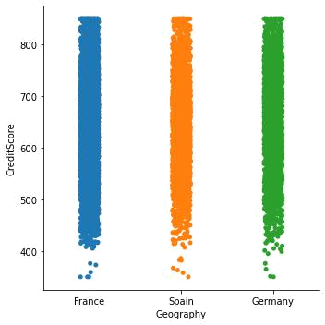

3. Multivariate

sns.relplot(x='Age',y='Balance',hue='Geography',data=df)

<seaborn.axisgrid.FacetGrid at 0x1fd1956e580>
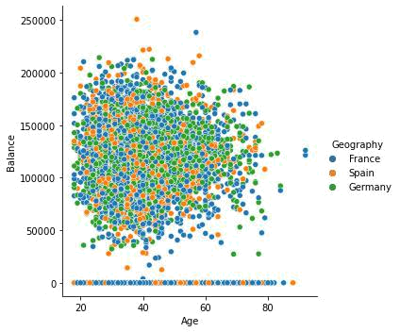

sns.boxplot(x='Exited',y='CreditScore',hue='Gender',data=df)

# for categorical data

<AxesSubplot:xlabel='Exited', ylabel='CreditScore'>
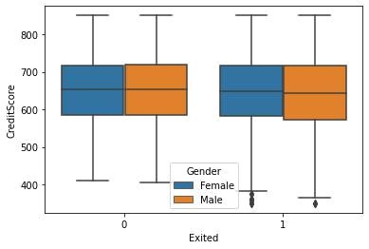

Descriptive Statistics

df.describe()

RowN
umbe
r

^{co} 10000.

^{un} 00000 t

- 5000.5
^{ea}0000
n

st 2886.8

- 9568

mi 1.0000
- 0

- 2500.7

%5000

Custo
merId

1.0000
00e+0
4

1.5690

94e+0
7

7.1936
19e+0

4

1.5565
70e+0
7

1.5628
53e+0
7

Credit |  | Tenur | Balanc | NumOf
Credit | Age | Tenur | Balanc | Product
Score | Age | e | e | Product
Score |  | e | e | s
10000. | 10000. | 10000. | 10000. | 10000.0
00000 | 00000 | 00000 | 10000. | 10000.0
00000 | 00000 | 00000 | 000000 | 00000
0 | 0 | 0 | 000000 | 00000
650.52 | 38.921 | 5.0128 | 76485. | 1.53020
8800 | 800 | 00 | 889288 | 0
96.653 | 10.487 | 2.8921 | 62397. | 0.58165
299 | 806 | 74 | 405202 | 4
350.00 | 18.000 | 0.0000 | 0.0000 | 1.00000
0000 | 000 | 00 | 00 | 0
584.00 | 32.000 | 3.0000 | 0.0000 | 1.00000
0000 | 000 | 00 | 00 | 0

HasC

rCard

10000
.0000
0

0.705
50

0.455

84

0.000
00

0.000
00

IsActive | Estimat
Membe | edSalar
r | y
10000.0 | 10000.0
00000 | 00000
0.51510 | 100090.
0 | 239881
0.49979 | 57510.4
7 | 92818
0.00000 | 11.5800
0 | 00
0.00000 | 51002.1
0 | 10000

Exited

10000.
00000
0

0.2037
00

0.4027

69

0.0000
00

0.0000
00

 | RowN | Custo | Credit |  | Tenur | Balanc | NumOf | HasC | IsActive | Estimat
 | umbe | Custo | Credit | Age | Tenur | Balanc | Product | HasC | Membe | edSalar | Exited
 | umbe | merId | Score | Age | e | e | Product | rCard | Membe | edSalar | Exited
 | r | merId | Score |  | e | e | s | rCard | r | y
50 | 5000.5 | 1.5690 | 652.00 | 37.000 | 5.0000 | 97198. | 1.00000 | 1.000 | 1.00000 | 100193. | 0.0000
50 | 5000.5 | 74e+0
% | 0000 | 74e+0 | 0000 | 000 | 00 | 540000 | 0 | 00 | 0 | 915000 | 00
% | 0000 | 7
75 | 7500.2 | 1.5753 | 718.00 | 44.000 | 7.0000 | 127644 | 2.00000 | 1.000 | 1.00000 | 149388. | 0.0000
75 | 7500.2 | 23e+0 | 718.00 | 44.000 | 7.0000 | .24000
% | 5000 | 23e+0 | 0000 | 000 | 00 | .24000 | 0 | 00 | 0 | 247500 | 00
% | 5000 | 7 | 0000 | 000 | 00 | 0
m | 10000. | 1.5815 | 850.00 | 92.000 | 10.000 | 250898 | 4.00000 | 1.000 | 1.00000 | 199992. | 1.0000
m | 10000. | 69e+0 | 850.00 | 92.000 | 10.000 | .09000
ax | 00000 | 69e+0 | 0000 | 000 | 000 | .09000 | 0 | 00 | 0 | 480000 | 00
ax | 00000 | 7 | 0000 | 000 | 000 | 0

Handling the missing(null) values

df.isnull().any()

RowNumber False

CustomerId False

Surname False

CreditScore False

Geography False

Gender False

Age False

Tenure False

Balance False

NumOfProducts False

HasCrCard False

IsActiveMember False

EstimatedSalary False

Exited False

dtype: bool

df.isnull().sum()

RowNumber 0

CustomerId 0

Surname 0

CreditScore 0

Geography 0

Gender 0

Age 0

Tenure 0

Balance 0

NumOfProducts 0

HasCrCard 0

IsActiveMember 0

EstimatedSalary 0

Exited 0

dtype: int64

# Since no null values are found no need to handle

Split the data into dependent and independent variables

x=df.iloc[:,3:13].values

print(x.shape)

y=df.iloc[:,13:14].values

print(y.shape)

(10000, 10)

(10000, 1)

Finding and Replacing Outliers

df.skew()

C:\Users\LENOVO\AppData\Local\Temp\ipykernel_3336\1665899112.py:1: FutureWarning: Dropping of nuisance columns in DataFrame reductions (with 'numeric_only=None') is deprecated; in a future version this will raise TypeError. Select only valid columns before calling the reduction.

df.skew()

RowNumber 0.000000

CustomerId 0.001149

CreditScore -0.071607

Age 1.011320

Tenure 0.010991

Balance -0.141109

NumOfProducts 0.745568

HasCrCard -0.901812

IsActiveMember -0.060437

EstimatedSalary 0.002085

Exited 1.471611

dtype: float64

sns.boxplot(df["Age"])

<AxesSubplot:xlabel='Age'>
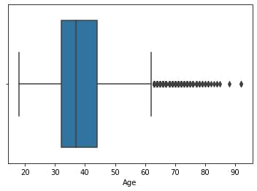

q1 = df["Age"].describe()["25%"]

q3 = df["Age"].describe()["75%"]

iqr = q3-q1

l_b = q1 -(1.5*iqr)

u_b = q3 + (1.5*iqr)

df[df["Age"]<l_b]

Row | Cust | Sur | Credi | Geog | Ge | A | Te | Bal | NumOf | HasC | IsActiv
Num | omer | na | tScor | raph | nd | g | nu | anc | Produc | rCar | eMemb
ber | Id | me | e | y | er | e | re | e | ts | d | er

df[df["Age"]>u_b]

 | Row | Cust | Surna | Cred | Geo | Ge | A | Te | Bal | NumO | Has | IsActiv
 | Num | omer | Surna | itSco | grap | nd | g | nu | anc | fProdu | CrC | eMemb
 | Num | omer | me
 | ber | Id | me | re | hy | er | e | re | e | cts | ard | er
5 |  | 1562 |  |  | Spai | Fe | 6
5 | 59 | 1562 | T'ien | 511 | Spai | ma | 6 | 4 | 0.00 | 1 | 1 | 0
8 | 59 | 3944 | T'ien | 511 | n | ma | 6
8 |  | 3944 |  |  | n | le | 6
8 |  | 1580 | Nduk |  | Spai | Fe | 7
8 | 86 | 1580 | Nduk | 652 | Spai | ma | 7 | 10 | 0.00 | 2 | 1 | 1
5 | 86 | 5254 | aku | 652 | n | ma | 5
5 |  | 5254 | aku |  | n | le | 5
1 |  | 1580 | Dunb |  | Spai | Fe | 6
0 | 105 | 1580 | Dunb | 670 | Spai | ma | 6 | 1 | 0.00 | 1 | 1 | 1
0 | 105 | 4919 | abin | 670 | n | ma | 5
4 |  | 4919 | abin |  | n | le | 5

Estimat edSalar y

Estima tedSala ry

1643.1
1

114675
.75

177655
.68

Ex

ite

d

Ex

ite

d

1

0

1

Row | Cust | Surna | Cred | Geo | Ge | A | Te | Bal | NumO | Has | IsActiv | Estima | Ex
Num | omer | Surna | itSco | grap | nd | g | nu | anc | fProdu | CrC | eMemb | tedSala | ite
Num | omer | me
ber | Id | me | re | hy | er | e | re | e | cts | ard | er | ry | d

1 |  | 1558 | Macle
5 | 159 | 1558 | Macle
5 | 159 | 9975 | an
8 |  | 9975 | an
1 |  | 1578
8 | 182 | 1578 | Hsia
8 | 182 | 9669 | Hsia
1 |  | 9669
... | ... | ... | ...
9
7 | 9754 | 1570 | Chied
5 | 9754 | 5174 | ozie
3
9
7 | 9766 | 1577 | Thom
6 | 9766 | 7067 | as
5
9 |  |  | Chuk
8 |  | 1581 | Chuk
8 | 9833 | 1581 | wujek
3 | 9833 | 4690 | wujek
3 |  | 4690 | wu
2 |  |  | wu
9
8 | 9895 | 1570 | Vagin
9 | 9895 | 4795 | Vagin
4
9
9 | 9937 | 1565 | Parks
3 | 9937 | 3037 | Parks
6

 | Fran | Fe | 7
646 | Fran | ma | 7
646 | ce | ma | 3
 | ce | le | 3
510 | Fran | Ma | 6
510 | ce | le | 5
... | ... | ... ...
 | Ger | Ma | 6
656 | man | Ma | 6
656 | man | le | 8
 | y | le | 8
445 | Fran | Ma | 6
445 | ce | le | 4
 | Ger | Fe | 6
595 | man | ma | 6
595 | man | ma | 4
 | y | le | 4
 | Fran | Fe | 7
521 | Fran | ma | 7
521 | ce | ma | 7
 | ce | le | 7
609 | Fran | Ma | 7
609 | ce | le | 7

 | 972
6 | 59.2 | 1 | 0 | 1
 | 5
2 | 0.00 | 2 | 1 | 1
... | ... | ... | ... | ...
 | 153
7 | 545. | 1 | 1 | 1
 | 11
 | 136
2 | 770. | 1 | 0 | 1
 | 67
 | 105
2 | 736. | 1 | 1 | 1
 | 32
6 | 0.00 | 2 | 1 | 1
1 | 0.00 | 1 | 0 | 1

104719
.66

48071.
61

...

186574
.68

43678.
06

89935.
73

49054.
10

18708.
76

0

0

...

0

0

1

0

0

359 rows × 14 columns

#Replace the outlier

outlier_list = list(df[df["Age"] > u_b]["Age"])

outlier_list

[66,

75,

65,

73,

65,

72,

67,

67,

79,

80,

68,

75,

66,

66,

70,

63,

72,

64,

64,

70,

67,

82,

63,

69,

65,

69,

64,

65,

74,

67,

66,

67,

63,

70,

71,

72,

67,

74,

76,

66,

63,

66,

68,

67,

63,

71,

66,

69,

73,

65,

66,

64,

69,

64,

77,

74,

65,

70,

67,

69,

67,

74,

69,

74,

74,

64,

63,

63,

70,

74,

65,

72,

77,

66,

65,

74,

88,

63,

71,

63,

64,

67,

70,

68,

72,

71,

66,

75,

67,

73,

69,

76,

63,

85,

67,

74,

76,

66,

69,

66,

72,

63,

71,

63,

74,

67,

72,

72,

66,

84,

71,

66,

63,

74,

69,

84,

67,

64,

68,

66,

77,

70,

67,

79,

67,

76,

73,

66,

67,

64,

73,

76,

72,

64,

71,

63,

70,

65,

66,

65,

80,

66,

63,

63,

63,

63,

66,

74,

69,

63,

64,

76,

75,

68,

69,

77,

64,

66,

74,

71,

67,

68,

64,

68,

70,

64,

75,

66,

64,

78,

65,

74,

64,

64,

71,

77,

79,

70,

81,

64,

68,

68,

63,

79,

66,

64,

70,

69,

71,

72,

66,

68,

63,

71,

72,

72,

64,

78,

75,

65,

65,

67,

63,

68,

71,

73,

64,

66,

71,

69,

71,

66,

76,

69,

73,

64,

64,

75,

73,

71,

72,

63,

67,

68,

73,

67,

64,

63,

92,

65,

75,

67,

71,

64,

66,

64,

66,

67,

77,

92,

67,

63,

66,

66,

68,

65,

72,

71,

76,

63,

67,

67,

66,

67,

63,

65,

70,

72,

77,

74,

72,

73,

77,

67,

71,

64,

72,

81,

76,

69,

68,

74,

64,

64,

71,

68,

63,

67,

63,

64,

76,

63,

63,

68,

67,

72,

70,

81,

67,

73,

66,

68,

71,

66,

63,

75,

69,

64,

69,

70,

71,

71,

66,

70,

63,

64,

65,

63,

67,

71,

67,

65,

66,

63,

73,

66,

64,

72,

71,

69,

67,

64,

81,

73,

63,

67,

74,

83,

69,

71,

78,

63,

70,

69,

72,

70,

63,

74,

80,

69,

72,

67,

76,

71,

67,

71,

78,

63,

63,

68,

64,

70,

78,

69,

68,

64,

64,

77,

77]

outlier_dict = {}.fromkeys(outlier_list,u_b)

outlier_dict

{66: 62.0,

- 62.0,

- 62.0,

- 62.0,

- 62.0,

- 62.0,

- 62.0,

- 62.0,

- 62.0,

- 62.0,

- 62.0,

- 62.0,

- 62.0,

- 62.0,

- 62.0,

- 62.0,

- 62.0,

- 62.0,

- 62.0,

- 62.0,

- 62.0,

- 62.0,

- 62.0,

- 62.0,

- 62.0}

df["Age"] = df["Age"].replace(outlier_dict)

sns.boxplot(df["Age"])

<AxesSubplot:xlabel='Age'>
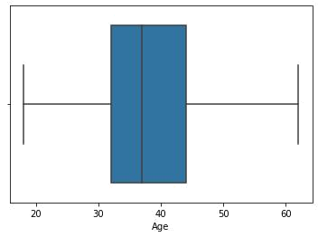

df[df["Age"]>u_b]

Row | Cust | Sur | Credi | Geog | Ge | A | Te | Bal | NumOf | HasC | IsActiv | Estimat | Ex
Num | omer | na | tScor | raph | nd | g | nu | anc | Produc | rCar | eMemb | edSalar | ite
ber | Id | me | e | y | er | e | re | e | ts | d | er | y | d

Check for Categorical columns and perform encoding.

from sklearn.compose import ColumnTransformer

from sklearn.preprocessing import OneHotEncoder

ct=ColumnTransformer([('oh',OneHotEncoder(),[1,2])],remainder='passthrough')

x=ct.fit_transform(x)

print(x.shape)

(10000, 13)

- saving the data import joblib joblib.dump(ct,"churnct.pkl")

['churnct.pkl']

Split the data into training and testing

from sklearn.model_selection import train_test_split

x_train,x_test,y_train,y_test = train_test_split(x,y,test_size=0.2,random_state=0)

print(x_train.shape)

print(x_test.shape)

(8000, 13)

(2000, 13)

Scale the independent variables

from sklearn.preprocessing import StandardScaler

sc=StandardScaler()

x_train=sc.fit_transform(x_train)

x_test=sc.transform(x_test)

joblib.dump(sc,"churnsc.pkl")

['churnsc.pkl']

